**1 .Install nginx and run nginx on port number 81.**

* connect to the remote machine by using: ssh -I “key pair” pem ec2-iser@ IP address.

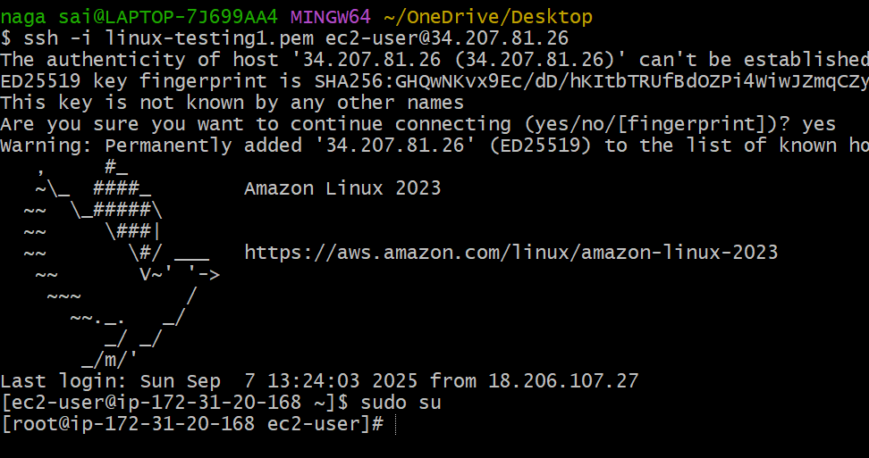

* Install nginx service – yum install nginx

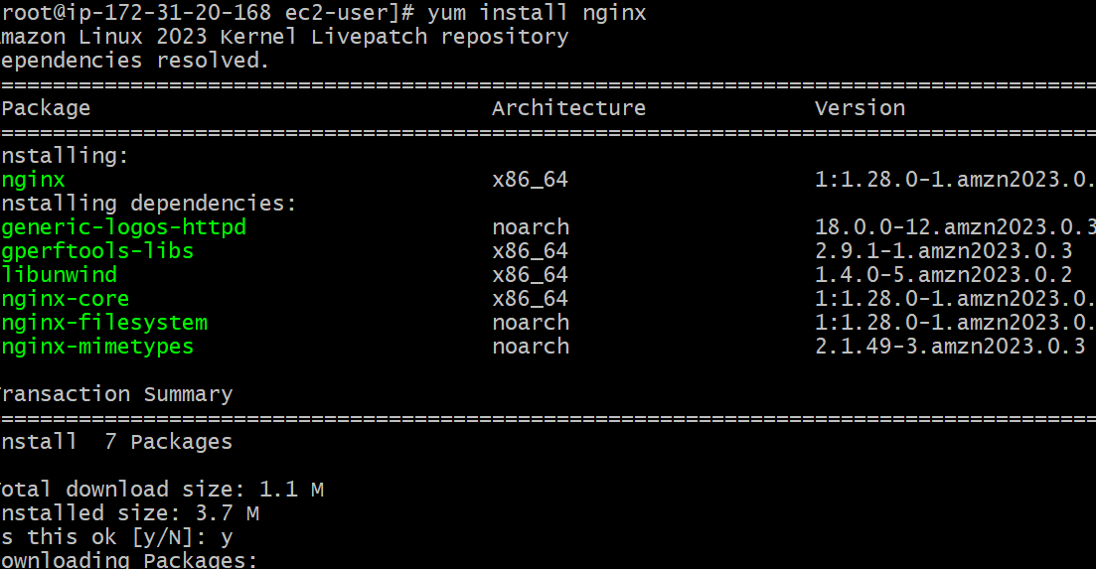

* start the nginx service - systemctl start nginx

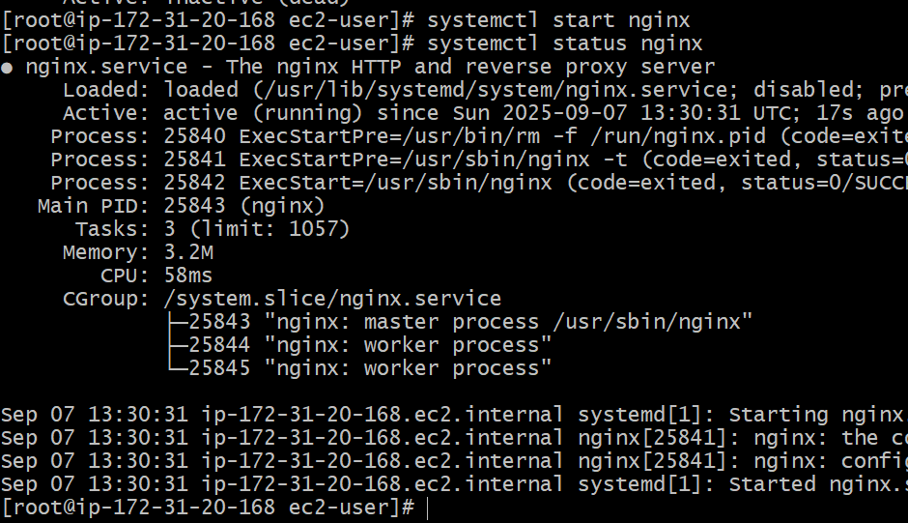

*By default it was running port on 80.



*find the file by using : file / -name nginx.conf and go to directory cd/etc/nginx.

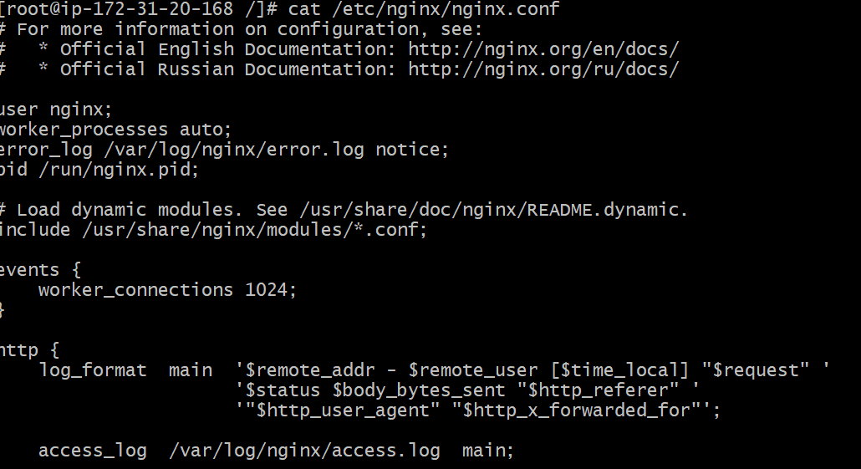

* change the configuration by from 80 to 81.

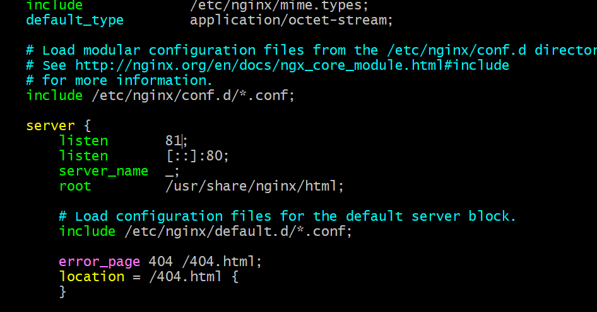

* Restart the system by using systemctl restart nginx.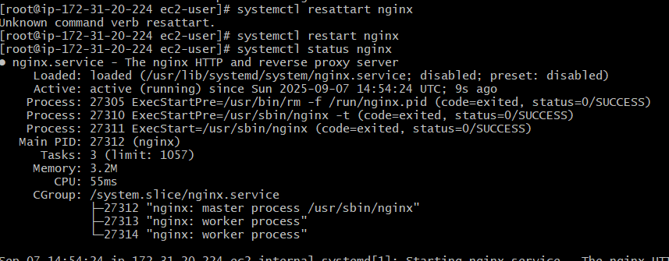

* Now, it was running on port on 81.



**2 -Deploy the sample html webpage on port 81**.

* Go to /usr/share/nginx/html/and create a file   
index.html



* Now, it was running on port 81.

**3 .Install apache and run apache on port number 82.**

* connect to the remote by using ssh -I pem key user@Ip address.

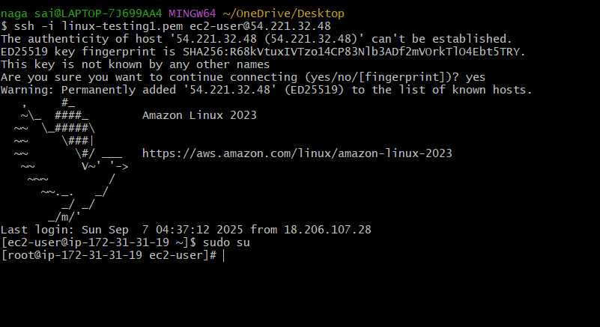

* install the httpd by using yum install httpd.

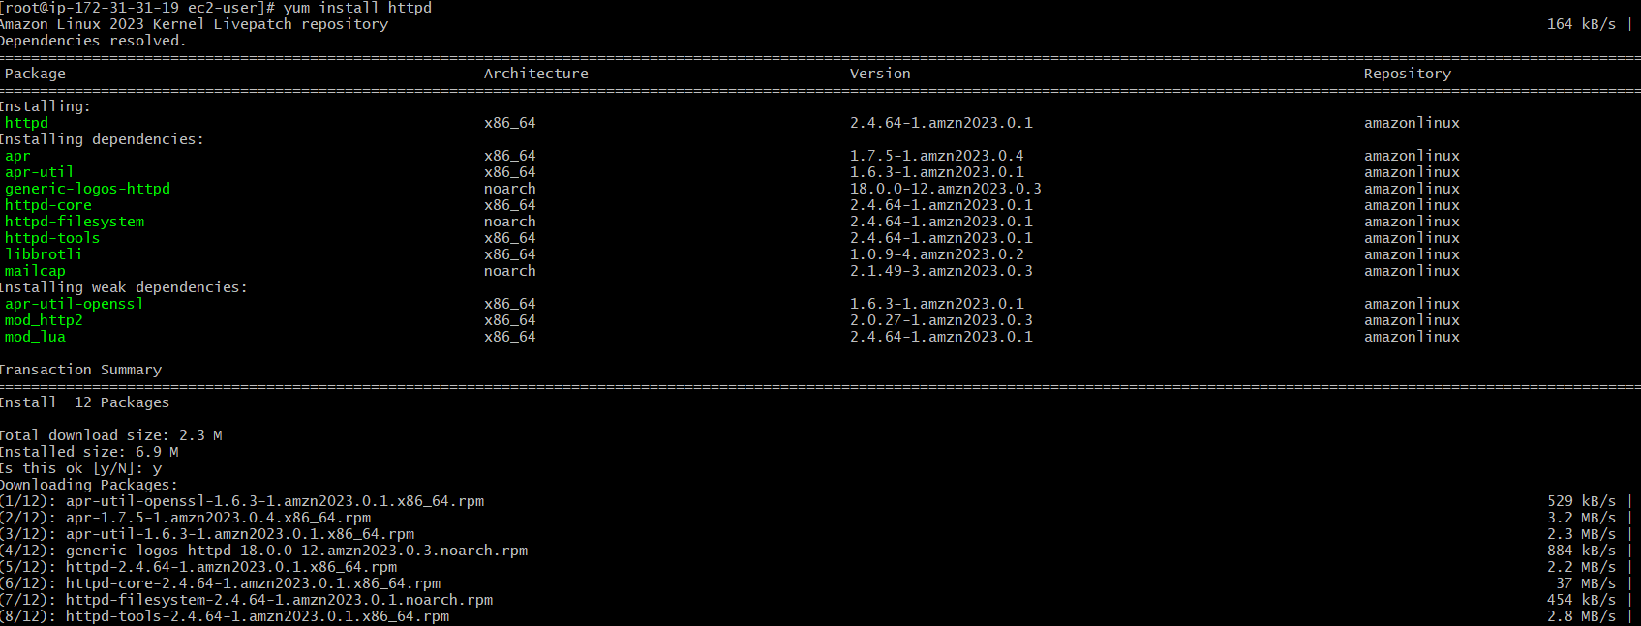

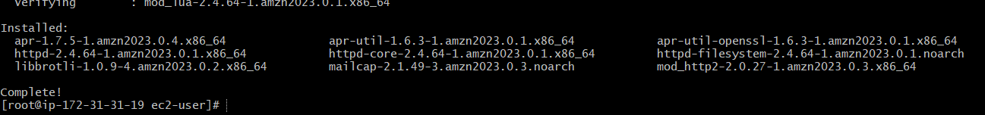

* start the httpd by using systemctl start httpd.

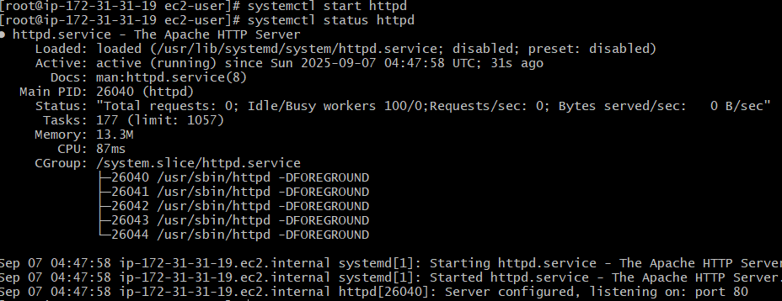

* Go to conf file by using find / - name



* change the conf file from 80 to 82.



* Now, it works on port 82.



**Deploy a sample index.html page on apache**

* Go to /var/www/html/page and create html page and add data

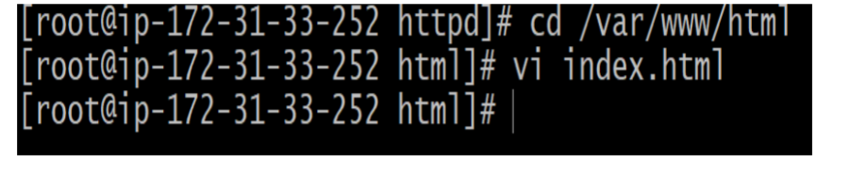



Task-5: **Install Apache tomcat on port number 8082**  
Go to google and search for apache tomcat download select version copy the link of the   
download file that is tar

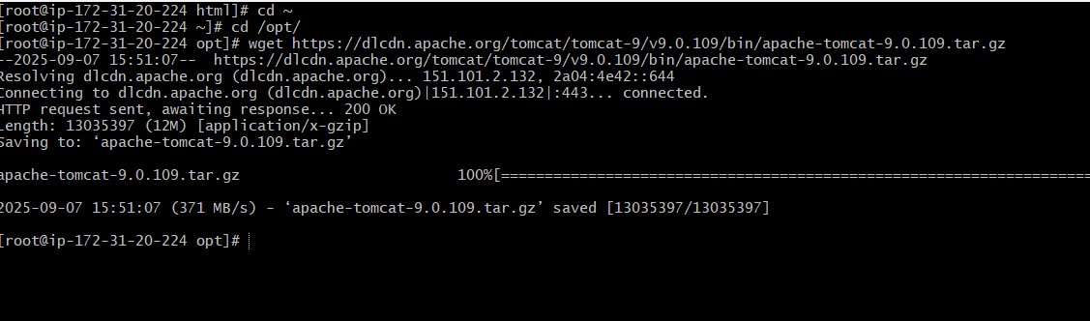

Here, we can extract the file from tar.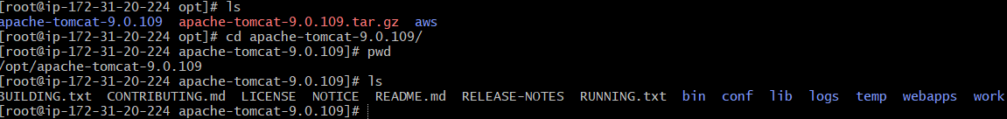



*for apache tomcat java is mandatory. By install it by using java –version.

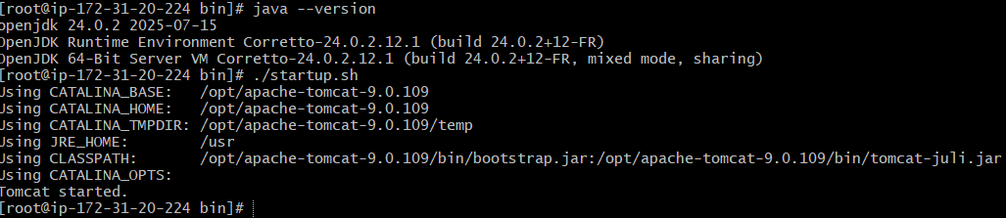

* check by using netstat -na | grep 80.

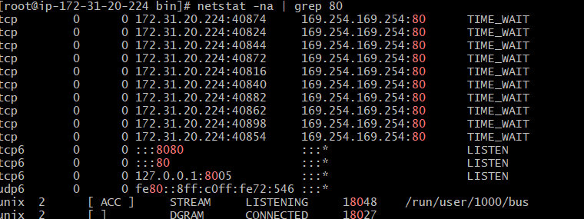





Go to conf file and edit the server.xml file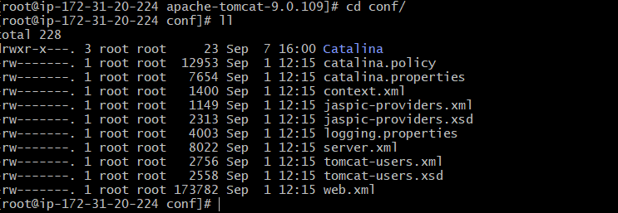



* change the port from 80 to 8082.

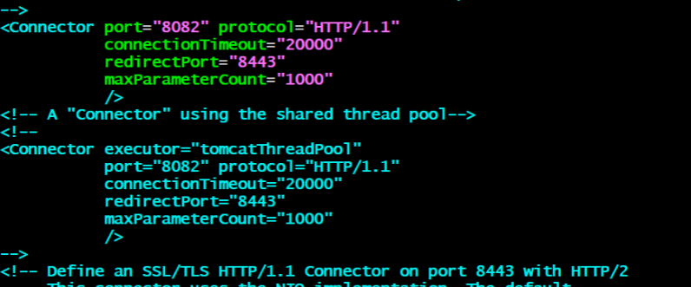



**Haproxy server**

1.launch 3 ec2 instances named as server1,server2,haproxy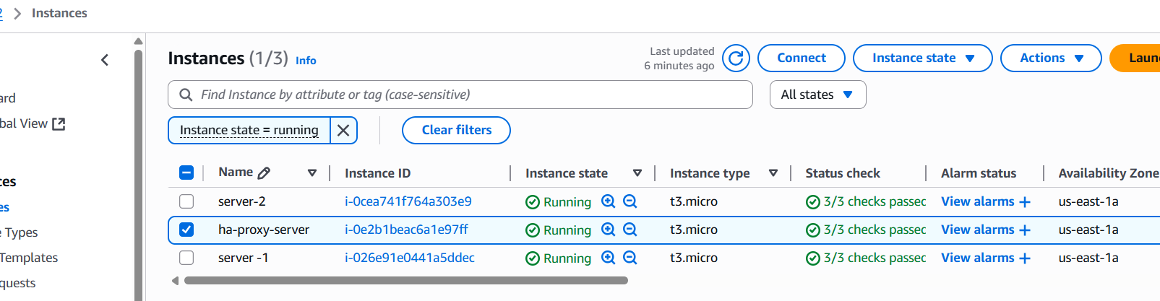

Connect to the remote server by using ssh.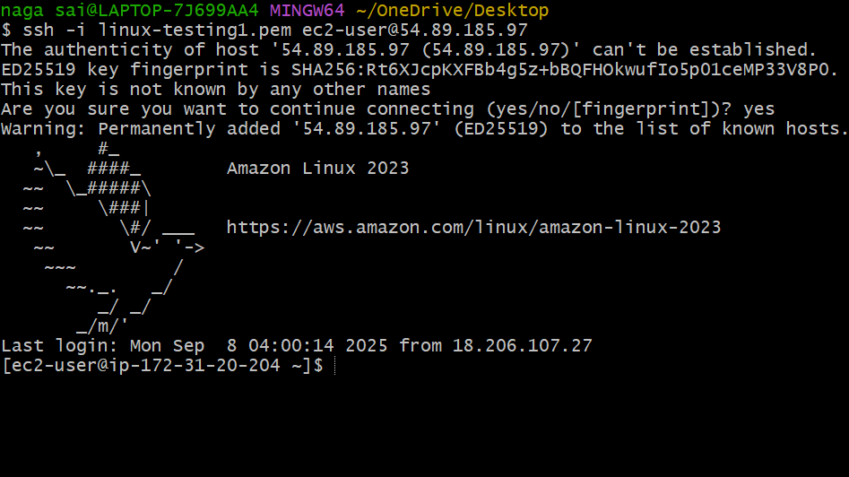

* yum update -y

*yum install httpd -y

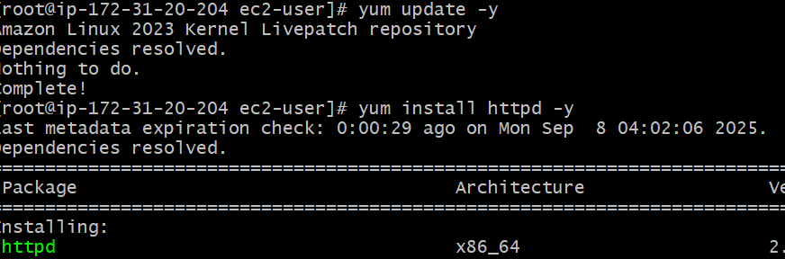

* vi /etc/hosts

*cat /etc/hosts

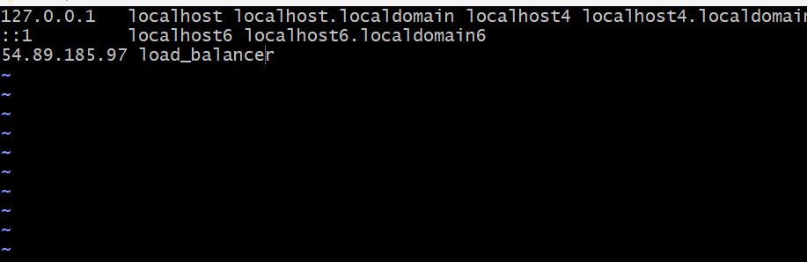

* run below command ping load _balancer -c 4



* start the httpd by using systemctl start httpd

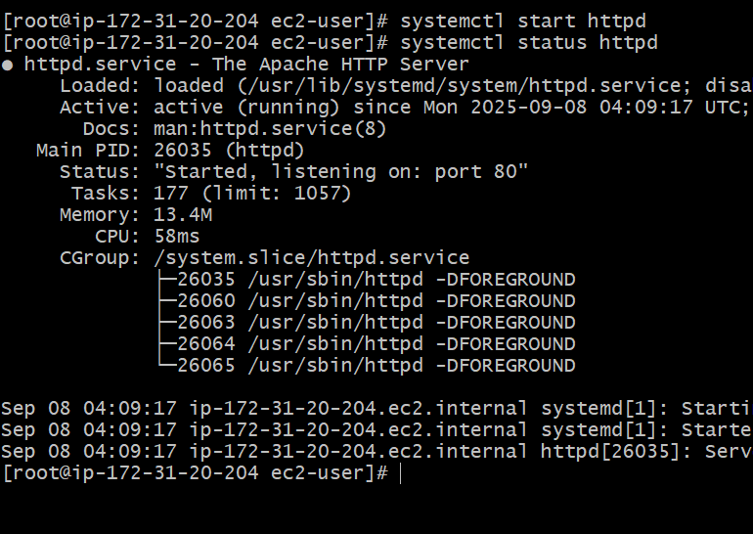

* connect to remote by using ssh -I .pem user@ip address.

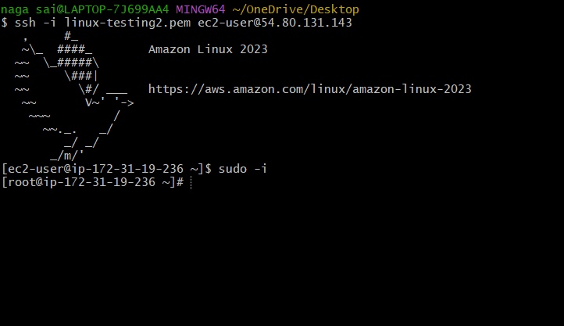

* yum update -y

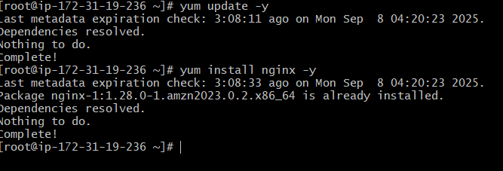

*vi /etc/hosts

*cat /etc/hosts

Add haproxy server public ip address

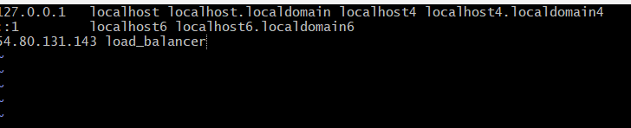

*run below command

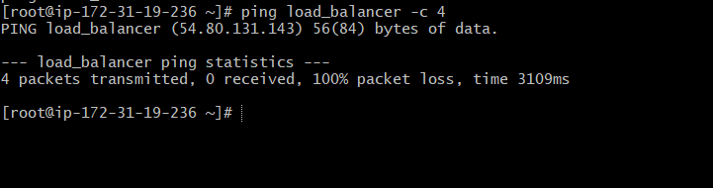

*start the nginx by using systemctl start nginx

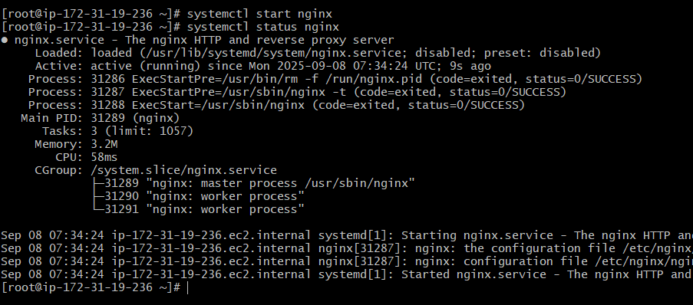

*connect to the remote by using ssh -I .pem user@ip address.

*sudo -i

*yum update -y

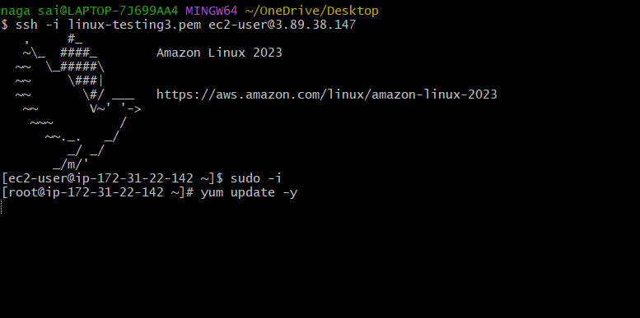

*install haproxy by using yum install haproxy -y

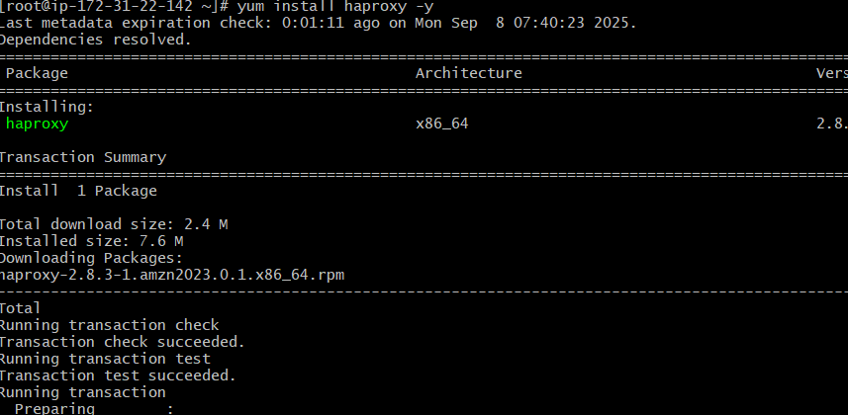

*vi /etc/hosts

Add server1.server 2 public ip address.

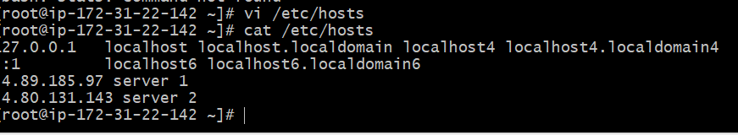

* vi/etc/haproxy/haproxy.cfg

Add server 1,server 2 public ip adrdress.

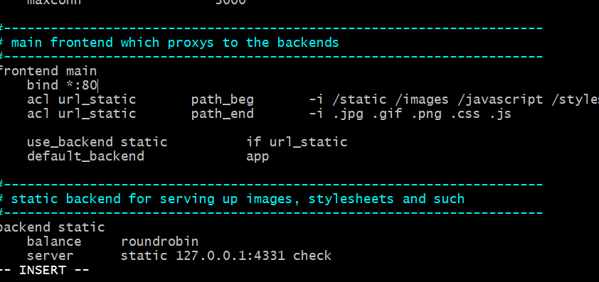

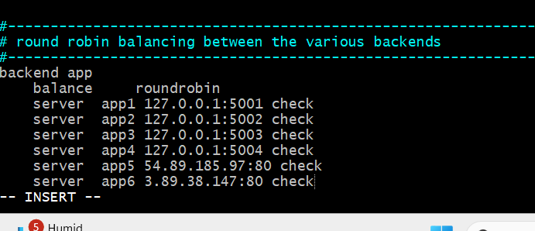

*systemctl enable haproxy

*systemctl start haproxy

*systemctl status haproxy

